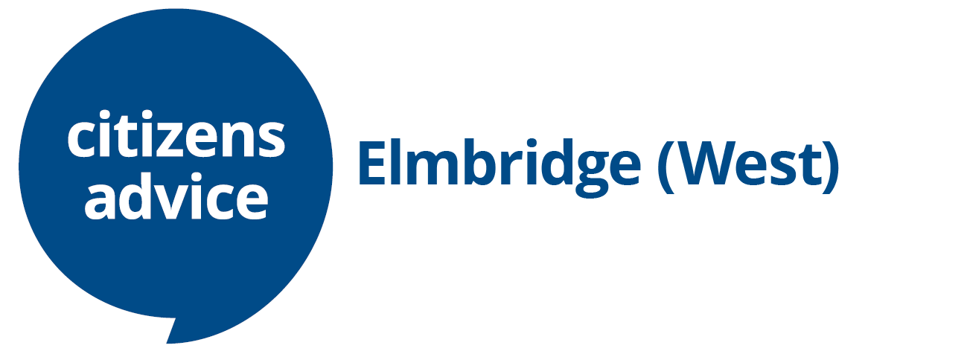
Young Adviser Intern
Job pack

Thanks for your interest in working within the Citizens Advice service. This job pack should give you everything you need to know to apply for this role and what it means to work within the Citizens Advice service.

In this pack you’ll find:
- Our values
- 3 things you should know about us
- Overview of the Citizens Advice service
- Role profile and terms and conditions
- The role profile and person specification

Our values
We’re inventive. We’re not afraid of trying new things and learn by getting things wrong. We question every idea to make it better and we change when things aren’t working.
We’re generous. We work together, sharing knowledge and experience to solve problems. We tell it like it is and respect everyone.
We’re responsible. We do what we say we’ll do and keep our promises. We remember that we work for a charity and use our resources effectively.
3 things you should know about us

1. We’re local and we’re national. We have 6 national offices and offer direct support to people in 279 independent local Citizens Advice services across England and Wales.

2. We’re here for everyone. Our advice helps people solve problems and our advocacy helps fix problems in society. Whatever the problem, we won’t turn people away.

3. We’re listened to - and we make a difference. Our trusted brand and the quality of our research mean we make a real impact on behalf of the people who rely on us.

Overview of the Citizens Advice service

The Citizens Advice service is made up of Citizens Advice - the national charity - and a network of around 300 local Citizens Advice members.
This role sits within our network of independent charities, delivering services from
● over 600 local Citizens Advice outlets
● over 1,800 community centres, GPs’ surgeries and prisons
They do this with:
● 6,500 local staff
● over 23,000 trained volunteers

Our reach means 99% of people in England and Wales can access a local Citizens Advice within a 30-minute drive of where they live.

Citizens Advice Elmbridge (West)
Citizens Advice Elmbridge (West) is a registered charity and a member of Citizens Advice. Our office helps thousands of people every year with issues including housing, debt, benefits, and employment. Our services are funded by local and national contracts and project grants, and we work with a range of stakeholders including local authorities, and community partners. We are an expanding local charity with 28 staff members working alongside over 40 volunteers to provide advice across Elmbridge (West)

What we give our staff
- Fantastic opportunities to launch and develop careers in the voluntary sector developing a wealth of useful knowledge, skills, and experience
- Excellent training opportunities
- An organisation that is committed to its employees, valuing their knowledge, well-being, creativity and flexibility
- The chance to work with amazing people within a nationally recognised charity
- A pension scheme with an employer contribution of 6%

Young Adviser Intern
12 months fixed term contract

Job Title: | Young Adviser Intern
Reporting to: | Youth Services Manager
Salary: | £17,241
Hours of work | 36 hours a week
Location: | Elmbridge West
Role purpose: | - To be part of CA Service Delivery Team as a young adviser.  - To support the YCA project in outreach delivery and awareness workshops  - To assist with the quarterly youth forum meetings
Closing date and submission information | 30th May 2022
This is an exciting opportunity to join our growing team and influence change and improvement across the organisation.

We are seeking someone who is passionate about giving an effective service to those most in need and who is not afraid to drive change and improvement. You will need to demonstrate that you are a strong team player, with a strategic view as well as an eye for detail, and have great people skills. You will thrive in a busy environment and have a positive ‘can do’ attitude.
Main responsibilities and duties

Service Delivery | - Train to deliver advice as an assessor  - Prepare resources for the awareness sessions across the borough  - Support the Youth Services Manager with the delivery of the awareness sessions  - Inputting service user data into the case management system as required  .  - Assist with project development and ensuring the delivery meet the needs of young people 16 to 24 years
Training and Development | - Citizens Advice Training modules  - Case Management System training  - Facilitation and Presentation Skills  - Identifying personal development training needs

- Person specification
- Strong IT skills- use of Microsoft Word, Excel, and Power point (s)

- Good Communication skills, including the ability to research, analyse and interpret information, produce, and present reports verbally and in writing. (s)

- Developed personal skills- including being friendly, approachable, good listener and non- judgemental. (s)

- Able to engage with young people in the community

- Ability to deliver presentations to small groups

- Self- Motivation and dedication to training and improvement.

Skills marked with (s) will be used when shortlisting

For an application form – enquiries@caew.org.uk

Closing Date 30th May
Completed Applications to Margaret.bourne@caew.org.uk

