

Advice Session Supervisor

Job pack

Thanks for your interest in working within the Citizens Advice service. This job pack should give you everything you need to know to apply for this role and what it means to work within the Citizens Advice service.

In this pack you’ll find:
- Our values
- 3 things you should know about us
- Overview of the Citizens Advice service
- Role profile and terms and conditions
- The role profile and person specification

 Our values
We’re inventive. We’re not afraid of trying new things and learn by getting things wrong. We question every idea to make it better and we change when things aren’t working.
We’re generous. We work together, sharing knowledge and experience to solve problems. We tell it like it is and respect everyone.
We’re responsible. We do what we say we’ll do and keep our promises. We remember that we work for a charity and use our resources effectively.
 | 3 things you should know about us

1. We’re local and we’re national. We have 6 national offices and offer direct support to people in 279 independent local Citizens Advice services across England and Wales.

2. We’re here for everyone. Our advice helps people solve problems and our advocacy helps fix problems in society. Whatever the problem, we won’t turn people away.

3. We’re listened to - and we make a difference. Our trusted brand and the quality of our research mean we make a real impact on behalf of the people who rely on us.

 Overview of the Citizens Advice service

The Citizens Advice service is made up of Citizens Advice - the national charity - and a network of around 300 local Citizens Advice members.  This role sits within our network of independent charities, delivering services from  ● over 600 local Citizens Advice outlets  ● over 1,800 community centres, GPs’ surgeries and prisons  They do this with:  ● 6,500 local staff  ● over 23,000 trained volunteers  Our reach means 99% of people in England and Wales can access a local Citizens Advice within a 30-minute drive of where they live. | 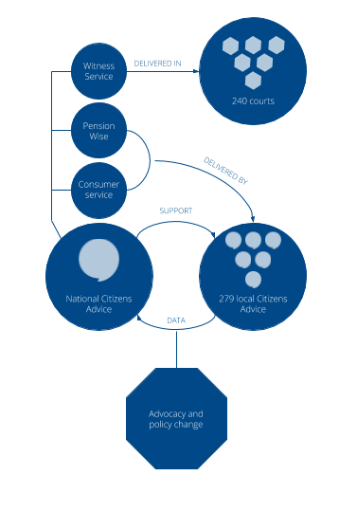

Citizens Advice Elmbridge (West)
Citizens Advice Elmbridge (West) is a registered charity and a member of Citizens Advice. Our office helps thousands of people every year with issues including housing, debt, benefits, and employment. Our services are funded by local and national contracts and project grants, and we work with a range of stakeholders including local authorities, and community partners. We are an expanding local charity with 28 staff members working alongside over 40 volunteers to provide advice across Elmbridge (West)

What we give our staff
- Fantastic opportunities to launch and develop careers in the voluntary sector developing a wealth of useful knowledge, skills, and experience
- Excellent training opportunities
- An organisation that is committed to its employees, valuing their knowledge, well-being, creativity, and flexibility
- The chance to work with amazing people within a nationally recognised charity
- A pension scheme with an employer contribution of 6%

Advice Session Supervisor
Vacancy

Job Title: | Advice Session Supervisor
Reporting to: | Head of Advice Services
Salary: | 27k FTE
Hours of work | 21 hours a week
Location: | Elmbridge West
Role purpose:
Closing date and submission information | 18th August 2022  Interview Date 26th August 2022
This is an exciting opportunity to join our growing team and influence change and improvement across the organisation. You will be advice trained with experience of delivering client facing sessions

We are seeking someone who is passionate about giving an effective service to those most in need and who is not afraid to drive change and improvement. You will need to demonstrate that you are a strong team player, with a strategic view as well as an eye for detail, and have great people skills. You will thrive in a busy environment and have a positive ‘can do’ attitude.
Main responsibilities and duties

Supervision | - Supervise, support, and direct the work of Advisers in the delivery of generalist advice service three days a week  - Support the development of volunteers into Advisers  - Manage the practicalities of advice sessions when on duty
Training and Development | - To assist with, supported interviews, assessed interviews and regular reviews of volunteers  - Identify the training needs of volunteers and contribute to the organisation’s training and development plan
General | - Attend regular meetings of paid and unpaid staff as required  - To abide by Health and Safety policies and procedures and share responsibility for your own safety and that of colleagues, clients, and visitors to the office  - To undertake any other duties as are necessary to ensure the effective delivery and development of the service and which are commensurate with the responsibilities of this post.

- Person specification
Essential
- Recent and ongoing experience of advice work.
- Understanding of the importance of support, development, and motivation.
- Ability to demonstrate how you keep knowledge up to date.
- A desire to constantly improve the service.
- Ability to communicate effectively both orally and in writing.
- Understanding of the issues involved in interviewing clients.
- Experience of working to prescribed quality standards.
- Ability to give and receive feedback objectively and sensitively and a willingness to challenge constructively.
- A flexible approach and the ability and willingness to work as part of a team.
- Ability to monitor and maintain recording systems and procedures, using IT as appropriate
- Understanding of and commitment to the aims and principles of the Citizens Advice service and its equal opportunities policies.

Desirable
- Experience of supervising staff and volunteer advice workers to achieve required standards.

- Appreciation of the local community and social challenges in the area

For an application form please email – enquiries@caew.org.uk

Closing Date 18th August 2022
Completed Applications to Margaret.bourne@caew.org.uk

