Administrator
Job pack
Thanks for your interest in working at Citizens Advice Elmbridge West. This job pack should give you everything you need to know to apply for this role and what it means to work at Citizens Advice.
In this pack you’ll find:

- Our values
- 3 things you should know about us
- Overview of Citizens Advice Citizens Elmbridge West
- The role profile and personal specification
- Terms and conditions
- What we give our staff

Our values
We’re inventive. We’re not afraid of trying new things and learn by getting things wrong. We question every idea to make it better and we change when things aren’t working.
We’re generous. We work together, sharing knowledge and experience to solve problems. We tell it like it is and respect everyone.
We’re responsible. We do what we say we’ll do and keep our promises. We
remember that we work for a charity and use our resources effectively.

3 things you should know about us
- We’re local and we’re national. We have 6 national offices and offer direct support to people in around 300 independent local Citizens Advice services across England and Wales.
- We’re here for everyone. Our advice helps people solve problems and our advocacy helps fix problems in society. Whatever the problem, we won’t turn people away.
- We’re listened to - and we make a difference. Our trusted brand and the quality of our research mean we make a real impact on behalf of the people who rely on us.
How Citizens Advice Elmbridge West works
Citizens Advice Elmbridge West provides advice services to over 4000 people each year with more than 20,000 issues. We deliver services to residents of Walton, Hersham and Weybridge for our CA services and we cover the boroughs of Elmbridge, Spelthorne and Epsom and Ewell with our Domestic Abuse Services. We provide the service with the help of around 40 volunteers and 30 staff who provide advice face-to-face in several locations as well as by telephone and email. Due to Covid our services a currently delivered predominantly by telephone but we are providing face-to-face services for the most vulnerable clients.

Citizens Advice  The Citizens Advice service is made up of Citizens Advice - the national charity and a network of around 300 independent charities local all of which are members of Citizens Advice.  The Citizens Advice network of independent charities, delivers services from  - over 600 local outlets  - over 1,800 community centres, GPs’  surgeries and prisons  and do this with:  - 6,500 local staff  - over 23,000 trained volunteers  Our reach means 99% of people in England and Wales can access a local Citizens Advice within a 30-minute drive of where they live. | 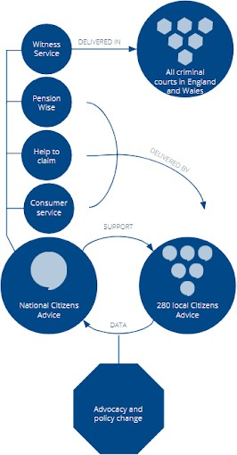

The role
The post holder will be responsible for providing a range of administrative support to the Domestic Abuse Sanctuary Scheme and more general administration support to cover some office admin tasks

Role profile

Administrative duties
  - Dealing with day-to-day incoming enquiries from clients, staff, and other agencies for the sanctuary scheme
  - Provide administrative support for the Sanctuary Scheme
  - Data inputting
  - Creating and maintain spreadsheets and databases

Working as part of a team
  - Be an active member of the wider team, acting and support colleagues in a collaborative way
  - Work with colleagues to maintain a positive working and learning environment, in which equality and diversity are valued and dignity at work is upheld.
  - Promote best practice across the team

Other duties and responsibilities
  - Carry out other tasks within the scope of the post to ensure the effective delivery and development of the service
  - Help to arrange events and meetings
  - Abide by health and safety guidelines and share responsibility for own safety and that of colleagues
  - To comply with all published organisational policies and procedures
  - Work flexibly to undertake such other reasonable duties and responsibilities

Person specification
  - Previous administrative experience with good current knowledge of Microsoft Office Packages
  - Ability to provide efficient administrative support and to maintain office systems with attention to detail and accuracy.
  - Excellent organisational skills with the ability to manage a varied workload, prioritise and meet deadlines under pressure.
  - Good interpersonal skills with the ability to communicate with people at all levels.
  - Able to work collaboratively as part of a team, with the self-motivation to work independently.
  - Ability to create and maintain efficient administration systems and records relevant to the role
  - Understanding of, and commitment to, the aims and principles of the Citizens Service in which equality and diversity is embedded throughout

Terms and conditions
The salary for the role will be £611.11
Hours: 10 hours week- Flexible working can be considered
Pension Scheme: Contribution of 6% based on 6% employee contribution
Location: Our office is in Walton on Thames Surrey

Applying for this post

To apply for this post, please request an application form from enquiries@caew.org.uk, Completed application forms should then be emailed to margaret.bourne@caew.org.uk. Please note that due to the urgency of making this appointment we have not stipulated a closing date and applications will be dealt with upon receipt.

